Australian Powerline Industries
1b Cross Street Brunswick East Victoria 3056
Phone 03 9387 1077 Fax 03 9387 2955

Meter and servicing equipment

M1120 NST TESTER
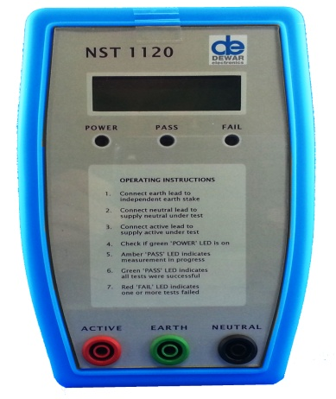
#####
HPST/1 PHASE TESTER
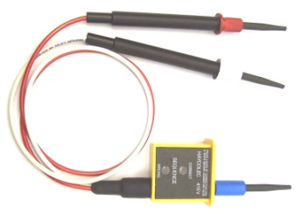

#####
HVT NEON VOLTAGE TESTER
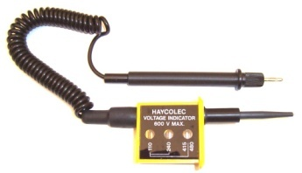

#####

HMC6415 MULTI TESTER
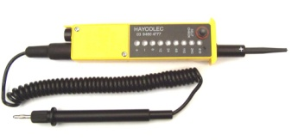
#####

3132 INSULATION TESTER
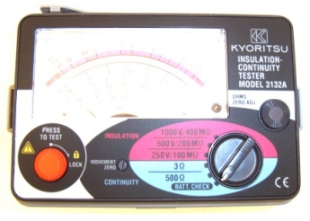
#####

KITSB RESCUE KIT
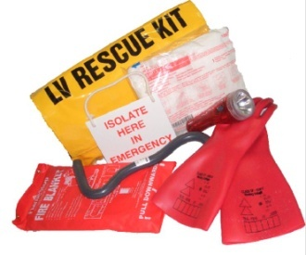
#####

HLRE10 EARTH REEL
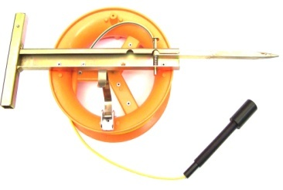
#####

HLRNW20 NEUTRAL REEL 20 MT
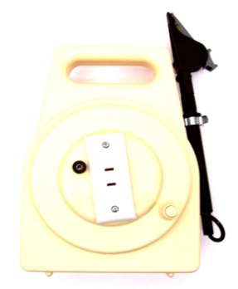
#####

EWR50 NEUTRAL REEL 50 MT
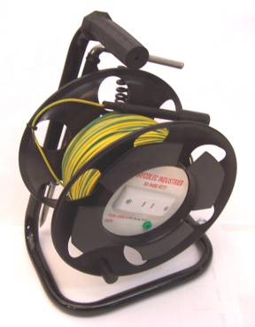
#####

EO650360 RUBBER ELECTRICAL GLOVES
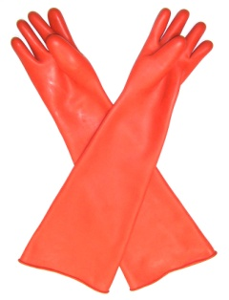
#####

MB600 MATS HV & LV
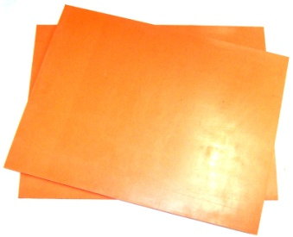
#####

HPST1200 LOAD TESTER
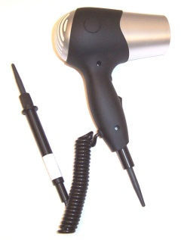
#####

FUSE REMOVAL STICKS

#####

TELESCOPIC STICKS
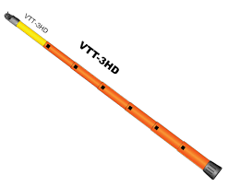
5455-10PTU FUSE REMOVER
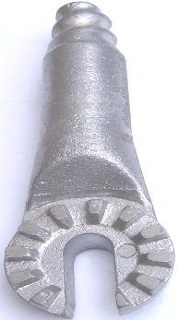

TB21 TOOL BOX
